OVERALL PROGRAMME EVALUATION REPORT
SEP Scale Alumni Masterclass Module 1 Uganda (11th May 2026 - 15th May 2026)
No. of Respondents: 47
No. of Participants: 47
Response Rate: 100%
--------------------------------------------------

Faculty Reports

Loise Wanjiru Oburu - Customers and competitor evaluation || Market potential evaluation || Customers, competitor and market planning
Evaluation Parameter | (%) Individual Score | (%) Programme Average
Punctuality (Commencement and Completion of Sessions) | 90 | 93
How well do you understand the core concepts presented? | 100 | 94
Rate your confidence in applying the new skills learnt | 90 | 87
Degree of Faculty preparedness for the sessions | 90 | 94
Content and methodology of the program | 90 | 94
Quality of class and group discussions | 80 | 88
The information presented in the course is relevant to my work (ministry) | 90 | 94
Average scores | 90 | 92

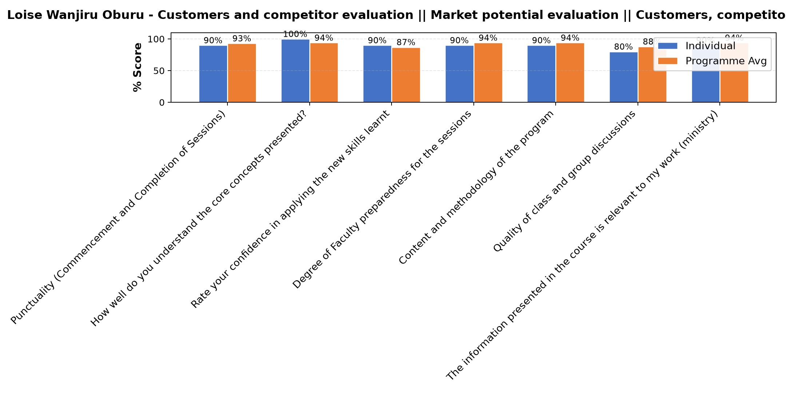

Comments & Feedback
- • Team work is needed kn my side to implement.

Dr. Cathy Mbidde - Reflect on Vision and Mission || Identify alignment to social enterprise
Evaluation Parameter | (%) Individual Score | (%) Programme Average
Punctuality (Commencement and Completion of Sessions) | 90 | 93
How well do you understand the core concepts presented? | 95 | 94
Rate your confidence in applying the new skills learnt | 90 | 87
Degree of Faculty preparedness for the sessions | 100 | 94
Content and methodology of the program | 95 | 94
Quality of class and group discussions | 95 | 88
The information presented in the course is relevant to my work (ministry) | 95 | 94
Average scores | 94 | 92

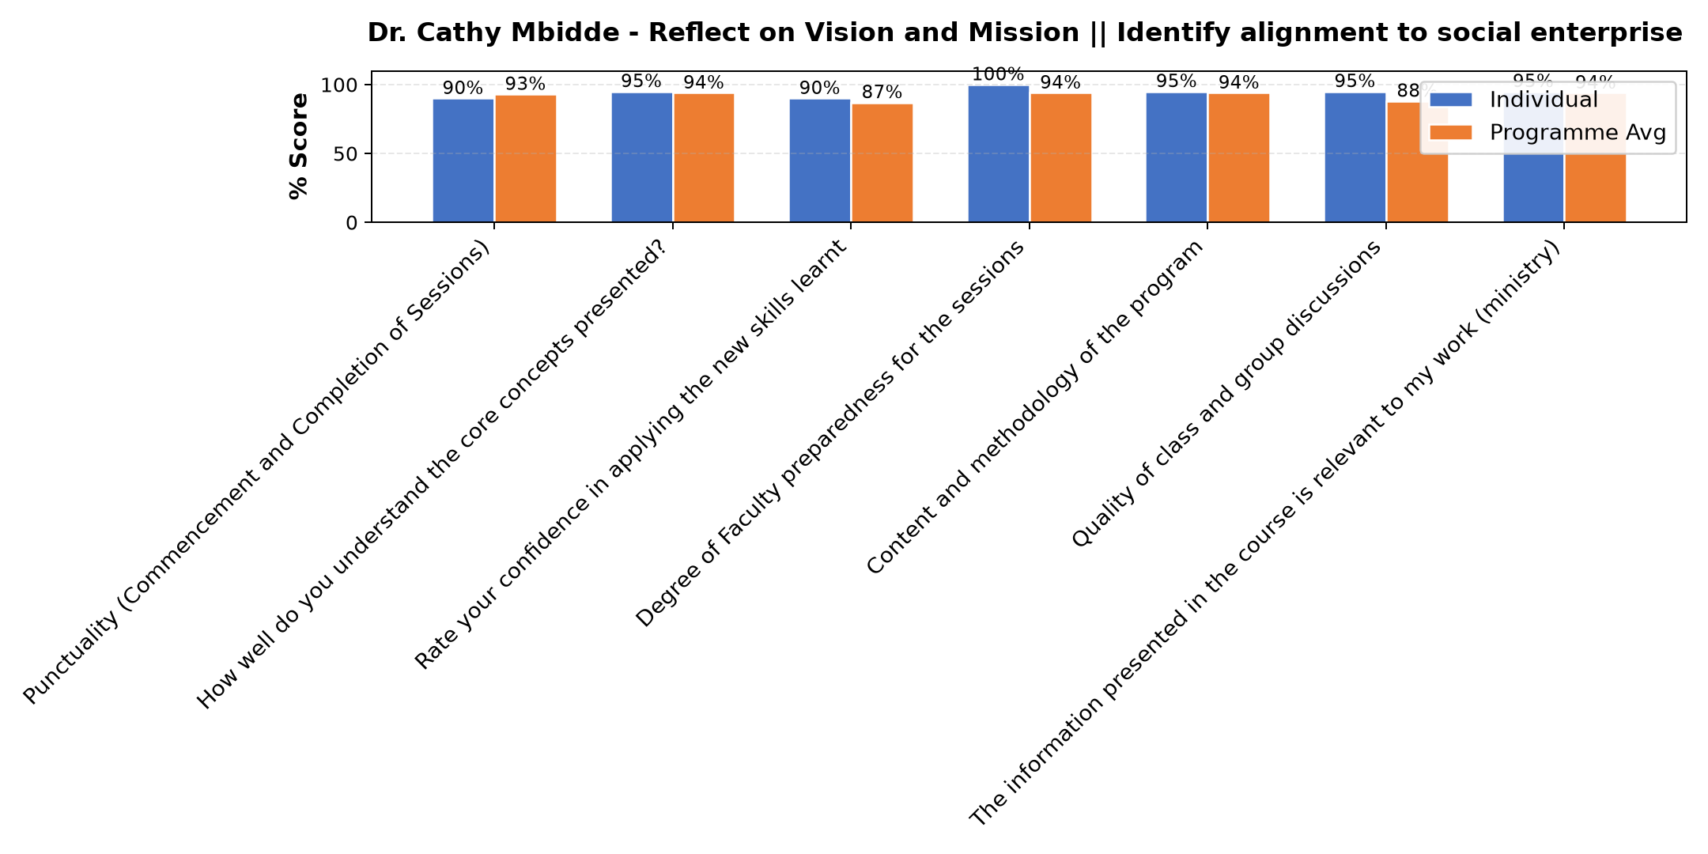

Comments & Feedback
- • Nothing can prevent me from applying this knowledge at all.

Dr. Tom Buringuriza - Reflection of SEP Learning
Evaluation Parameter | (%) Individual Score | (%) Programme Average
Punctuality (Commencement and Completion of Sessions) | 93 | 93
How well do you understand the core concepts presented? | 87 | 94
Rate your confidence in applying the new skills learnt | 87 | 87
Degree of Faculty preparedness for the sessions | 95 | 94
Content and methodology of the program | 93 | 94
Quality of class and group discussions | 92 | 88
The information presented in the course is relevant to my work (ministry) | 100 | 94
Average scores | 92 | 92

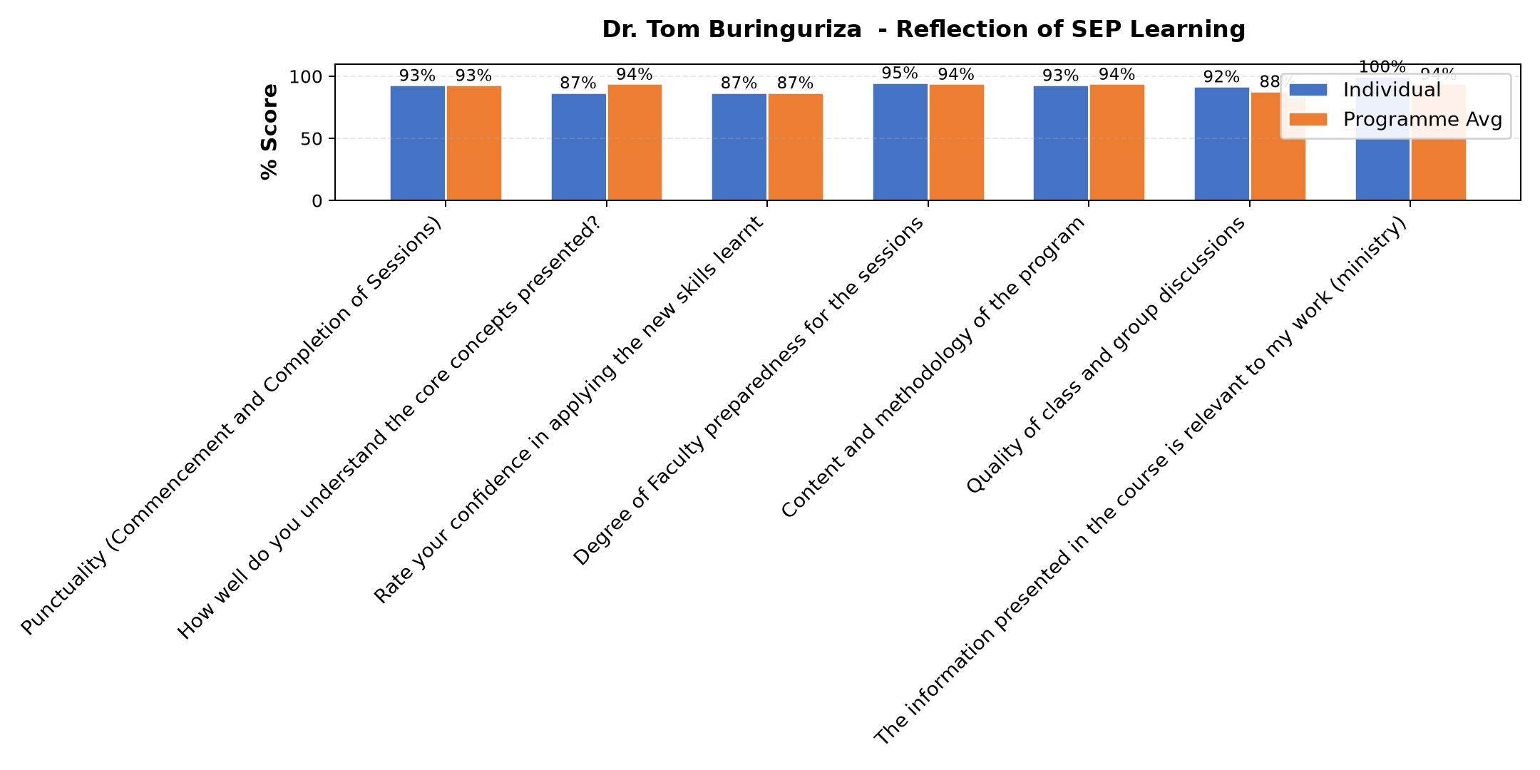

Comments & Feedback
- • Finances,
- • No barriers at all.
- • follow up session must be continuous
- • I will implement..no barrier
- • Busy work schedules
- • I aquired new ideas which have motivated me to chase our entrepreneurial goal.
- • Opportunity ,environment, negativity from others, lack of support and rejection to welcome my opinions
- • No barriers.
- • Busy work schedules
- • The costs of data are too high

Lenah Gachoki - Reflection on leadership and teams (employees)
Evaluation Parameter | (%) Individual Score | (%) Programme Average
Punctuality (Commencement and Completion of Sessions) | 100 | 93
How well do you understand the core concepts presented? | 93 | 94
Rate your confidence in applying the new skills learnt | 80 | 87
Degree of Faculty preparedness for the sessions | 90 | 94
Content and methodology of the program | 97 | 94
Quality of class and group discussions | 87 | 88
The information presented in the course is relevant to my work (ministry) | 93 | 94
Average scores | 91 | 92

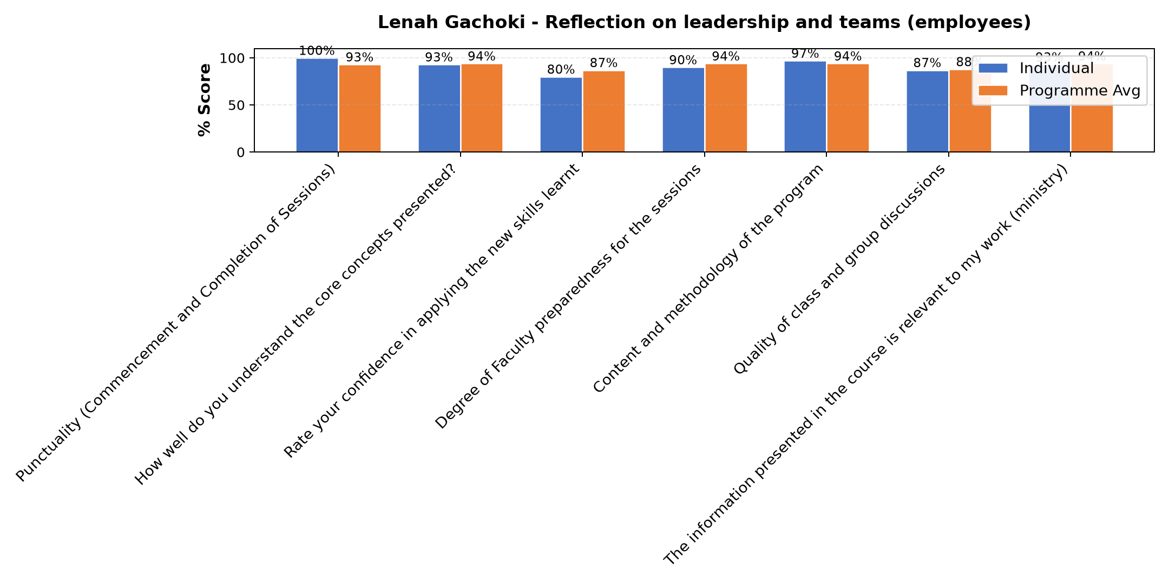

Comments & Feedback
- • I don't see any barriers. Am going to apply for the values learned
- • Lack of enough self knowledge
- • Maybe it's the moment of time.hunger and luck of self motivation

Department Reports

Further Comments

Comments & Feedback
- • That was a good comand of the subject
- • Thanks

Further Comments

Comments & Feedback
- • It was good one
- • Share with us the slides if you don't mind.
The presentation was all perfect dear Lena.
- • Thank you for knowledge sharing
- • Talk about the benefits of being a good leader as an individual as well as the team
- • Thanks for the leadership session. It was very good and clear
- • It was quite enriching
- • Grateful for the input
- • If possible once in while to give data sometimes it gets over and I miss some sharing.
- • I appreciate
- • To remain focus on the vision of the congregation

Further Comments

Comments & Feedback
- • It has been a wonderful input.
- • Thank you.
- • Thanks for giving me the opportunity to grow my knowledge
- • Require more input sessions
- • I
- • He was very clear and the presentation was ok
- • Educative and constructive seminars
- • The in put is very nice and I am ready to use it.
- • I have reminded myself of what i had learnt
- • The presentation was generally good.
- • He was audible enough

